**Topics: Descriptive Statistics and Probability**

1. Look at the data given below. Plot the data, find the outliers and find out $μ, σ, σ^{2}$

|  |  |
| --- | --- |
| **Name of company** | **Measure X** |
| Allied Signal | 24.23% |
| Bankers Trust | 25.53% |
| General Mills | 25.41% |
| ITT Industries | 24.14% |
| J.P.Morgan & Co. | 29.62% |
| Lehman Brothers | 28.25% |
| Marriott | 25.81% |
| MCI | 24.39% |
| Merrill Lynch | 40.26% |
| Microsoft | 32.95% |
| Morgan Stanley | 91.36% |
| Sun Microsystems | 25.99% |
| Travelers | 39.42% |
| US Airways | 26.71% |
| Warner-Lambert | 35.00% |

Solution:

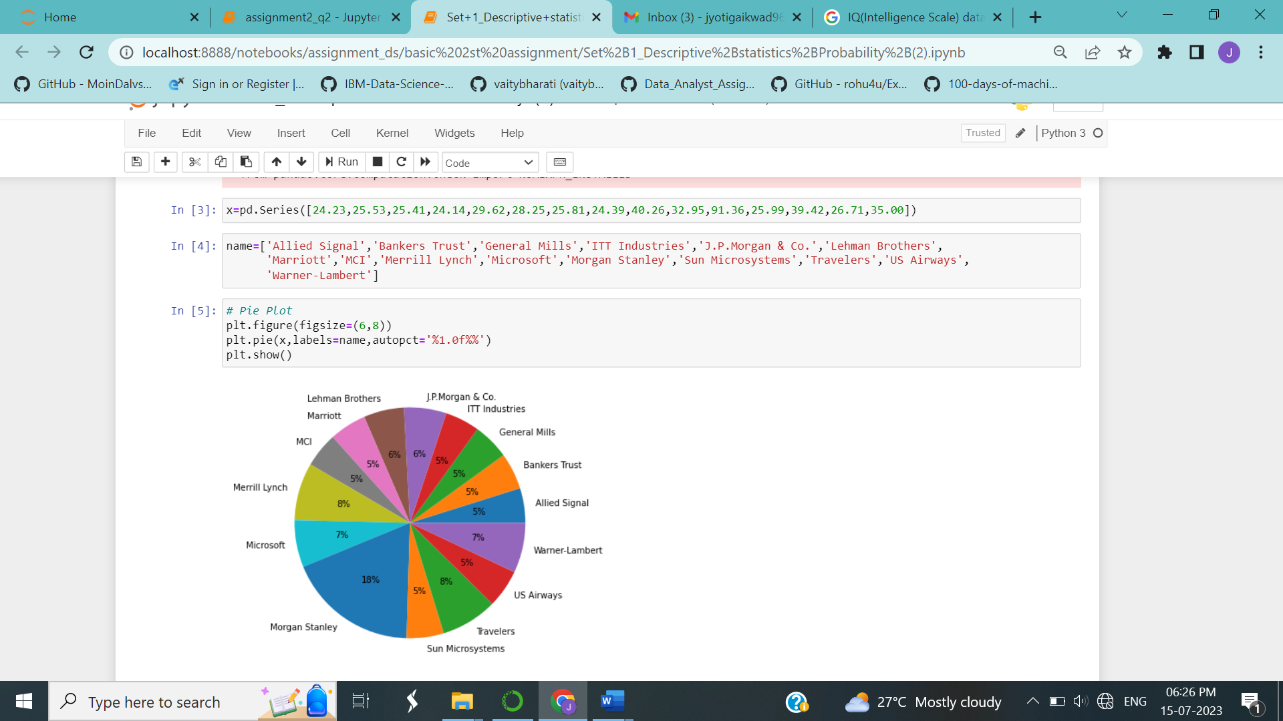

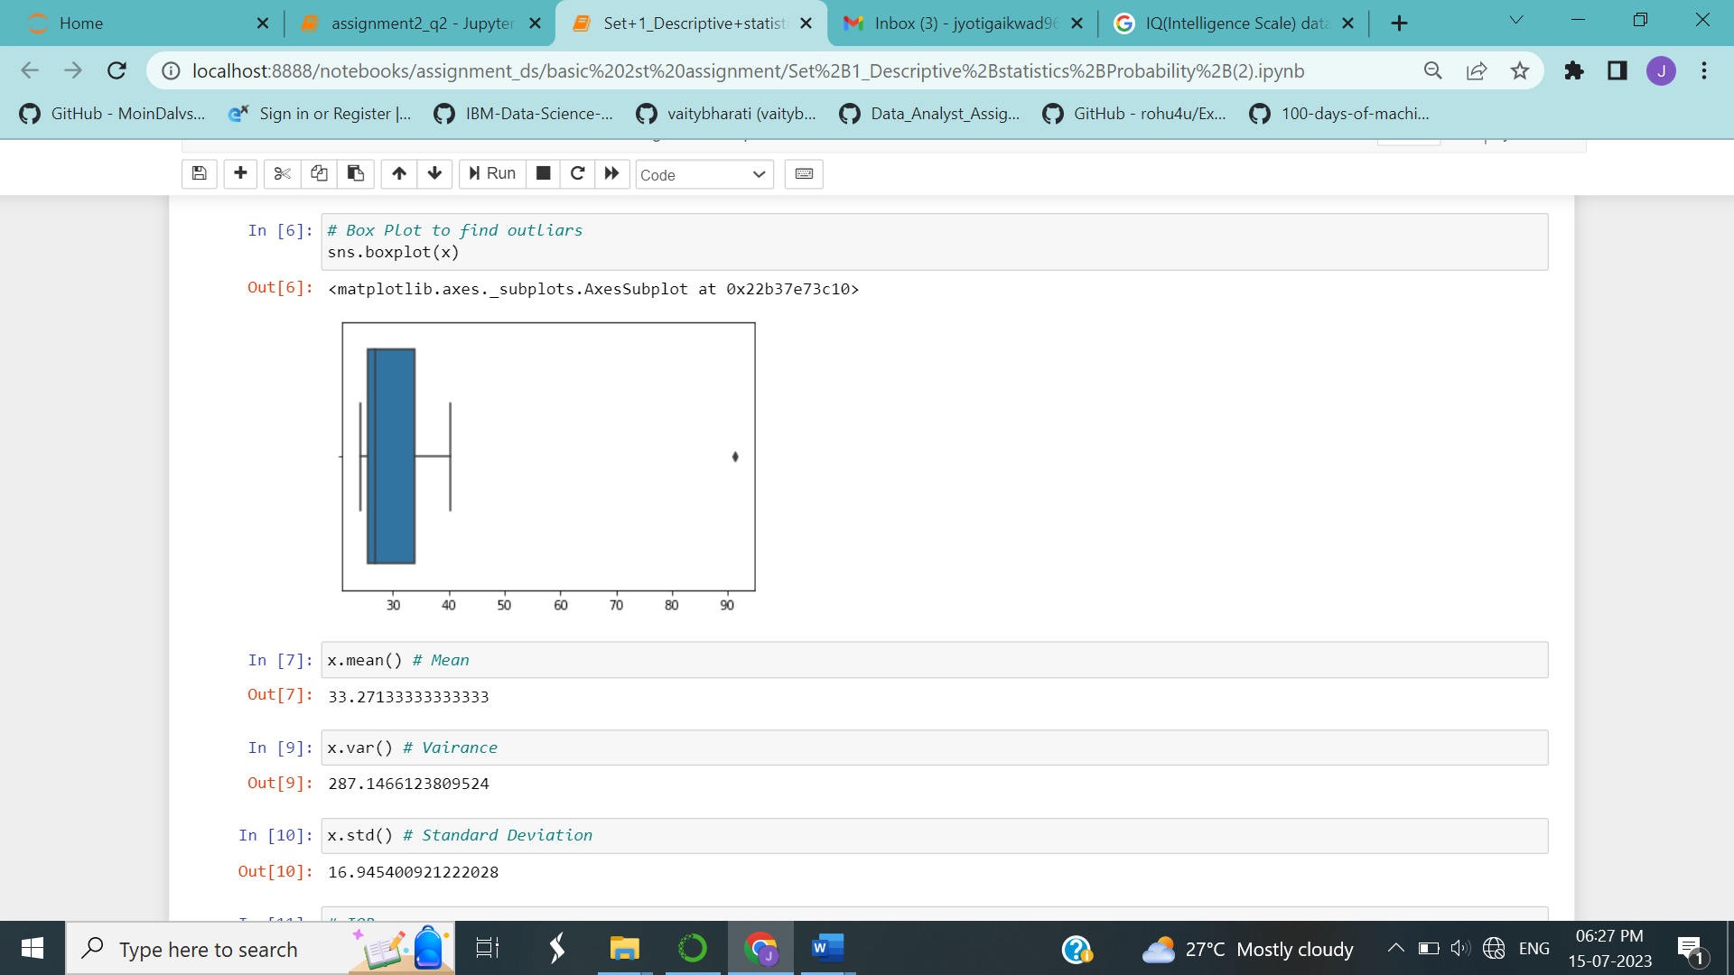

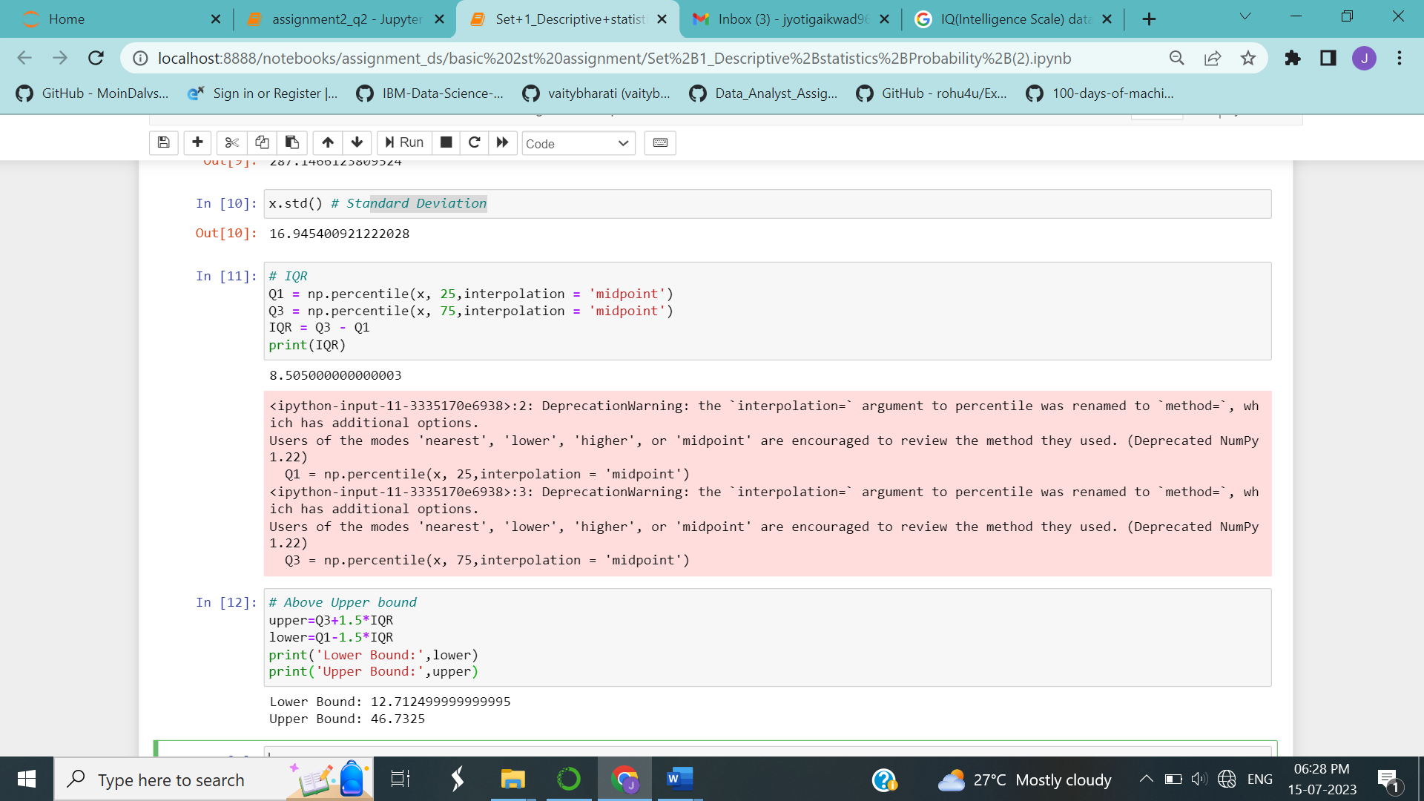

Mean (μ): 33.271

Variance ($σ$): 287.146

Standard deviation ($σ^{2}$): 16.945

The values less than 12.712 (Lower Bound) and greater than 46.73 (Upper Bound) are outliers

i.e Morgan Stanley: 91.36



Answer the following three questions based on the box-plot above.

1. What is inter-quartile range of this dataset? (please approximate the numbers) In one line, explain what this value implies.

Ans: IQR =12 - 5 = 7, this represents the range which contains 50% of the data points.

1. What can we say about the skewness of this dataset?

Ans: Right skewed

1. If it was found that the data point with the value 25 is actually 2.5, how would the new box-plot be affected?

Ans: 2.5 will be not considered an outlier. The boxplot will start from 0 and end at 20 in representation.



Answer the following three questions based on the histogram above.

1. Where would the mode of this dataset lie?

Ans: Mode lies between 4 and 8.

1. Comment on the skewness of the dataset.

Ans: Dataset is right skewed

1. Suppose that the above histogram and the box-plot in question 2 are plotted for the same dataset. Explain how these graphs complement each other in providing information about any dataset.

Ans: Median in boxplot and Mode in histogram, Histogram provides the frequency distribution so we can see how many times each data point is occurring. however, boxplot provides the quantile distribution i.e., 50% data lies between 5 and 12. Boxplot provides whisker length to identify outliers, no information from histogram. We can only guess looking at the gap that 25 may be an outlie.

1. AT&T was running commercials in 1990 aimed at luring back customers who had switched to one of the other long-distance phone service providers. One such commercial shows a businessman trying to reach Phoenix and mistakenly getting Fiji, where a half-naked native on a beach responds incomprehensibly in Polynesian. When asked about this advertisement, AT&T admitted that the portrayed incident did not actually take place but added that this was an enactment of something that “could happen.” Suppose that one in 200 long-distance telephone calls is misdirected. What is the probability that at least one in five attempted telephone calls reaches the wrong number? (Assume independence of attempts.)

Ans: **Given**: one in 200 long-distance telephone calls is misdirected.

**To find:** probability that at least one in five attempted telephone calls reaches the wrong number

probability of call misdirecting, p= 1/200

Probability of call not Misdirecting, q = 1 - 1/200 = 199/200

Number of Calls = 5

P(x) = ⁿCₓ pˣ qⁿ⁻ˣ

n = 5, p = 1/200, q = 199/200

At least one in five attempted telephone calls reaches the wrong number

= 1 - None of the call reaches the wrong number

= 1 - P(0)

= 1 - ⁵C₀(1/200)⁰(199/200)⁵⁻⁰

= 1 - (199/200)⁵

= 0.02475

1. Returns on a certain business venture, to the nearest $1,000, are known to follow the following probability distribution

|  |  |
| --- | --- |
| x | P(x) |
| -2,000 | 0.1 |
| -1,000 | 0.1 |
| 0 | 0.2 |
| 1000 | 0.2 |
| 2000 | 0.3 |
| 3000 | 0.1 |

1. What is the most likely monetary outcome of the business venture?

Ans: Most likely monetary outcome of the business venture is **$2000** as it has maximum P(x)=0.3

1. Is the venture likely to be successful? Explain

Ans: P(x>0) = 0.6, implies there is a 60% chance that the venture would yield profits or greater than expected returns. P (Incurring losses) is only 0.2. So, the venture is likely to be successful

1. What is the long-term average earning of business ventures of this kind? Explain

Ans: Expected value = ∑E(X)P(X) = 800

Long-term average earning of business ventures = $ 800

Venture is likely to be successful as Expected value is + ve = $800

1. What is the good measure of the risk involved in a venture of this kind? Compute this measure

Ans: P(loss) = P(x= -2000)+P(x=-1000)=0.2. So the risk associated with this venture is 20%.

The good measure of the risk involved in a venture of this kind depends on the Variability in the distribution. Higher Variance means more chances of risk

Var (X) = E(X2) –(E(X))2 = 2800000 – 8002 = 2160000